**CSA-1557 CLOUD COMPUTING**

**EXP 1:**

1. **Create a simple cloud software application for Flight Reservation System using any Cloud Service Provider to demonstrate SaaS include the necessary fields such as one way, round trip, From, to, Departure, Departure, Travelers & Class, Fare Type, International and Domestic Flights etc.**

**AIM:**

Create a simple cloud software application for Flight Reservation System using any Cloud Service Provider to demonstrate SaaS include the necessary fields such as one way, round trip, From, to, Departure, Departure, Travelers & Class, Fare Type, International and Domestic Flights etc.

**STEP 1:**

Login to zoho.com open zoho creator webpage and create a new component by selecting form option.

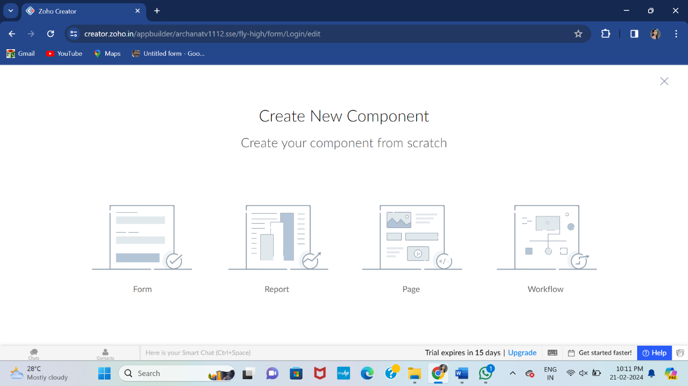

**STEP 2:**

Create a form by choosing from scratch option.

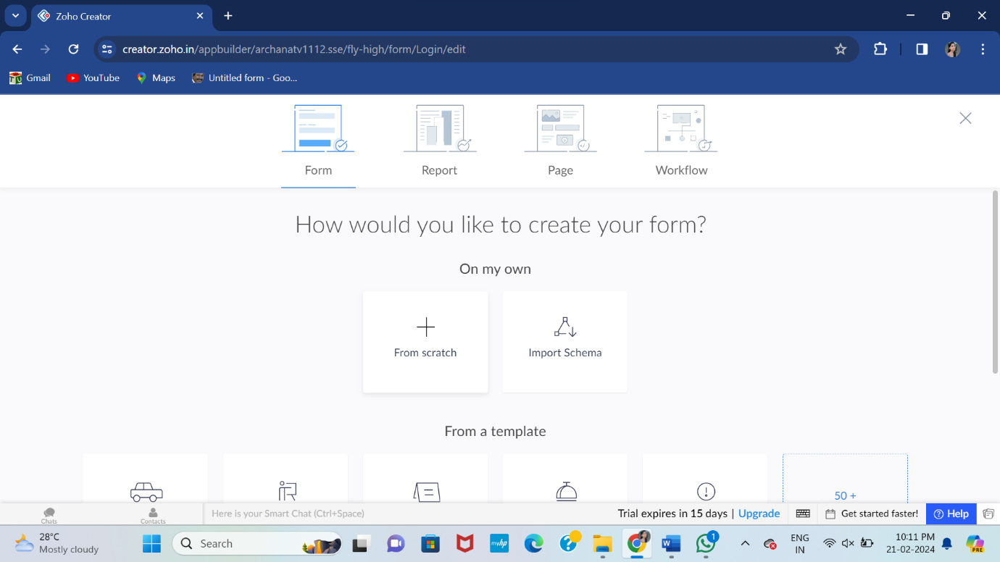

**STEP 3:**

After selecting the create from scratch name the form and create.

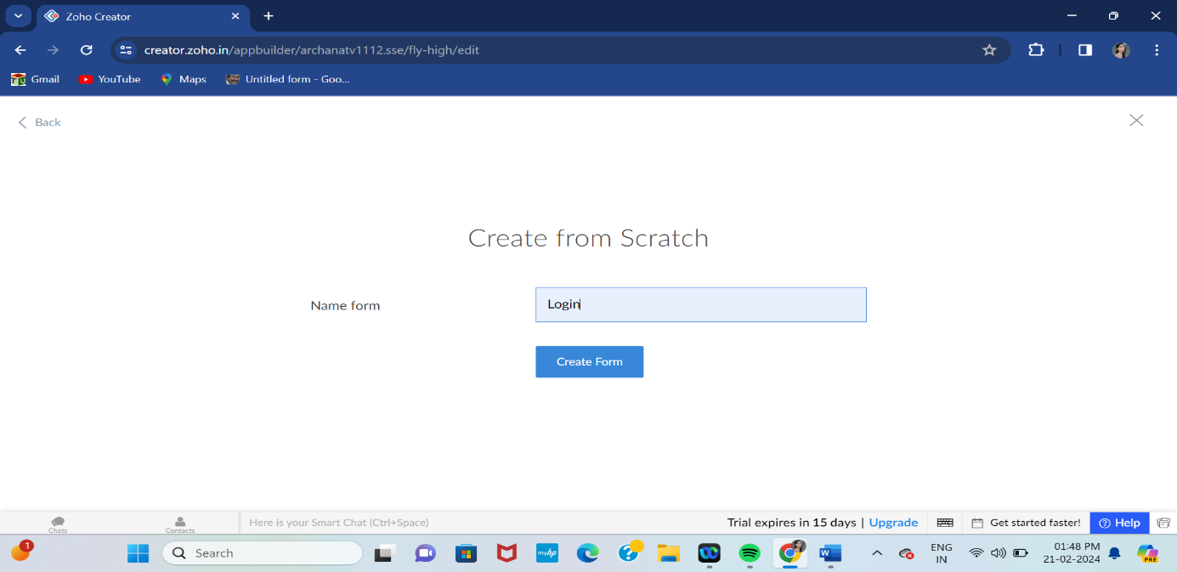

**STEP 4:**

Add the required basic fields to creating the login page.

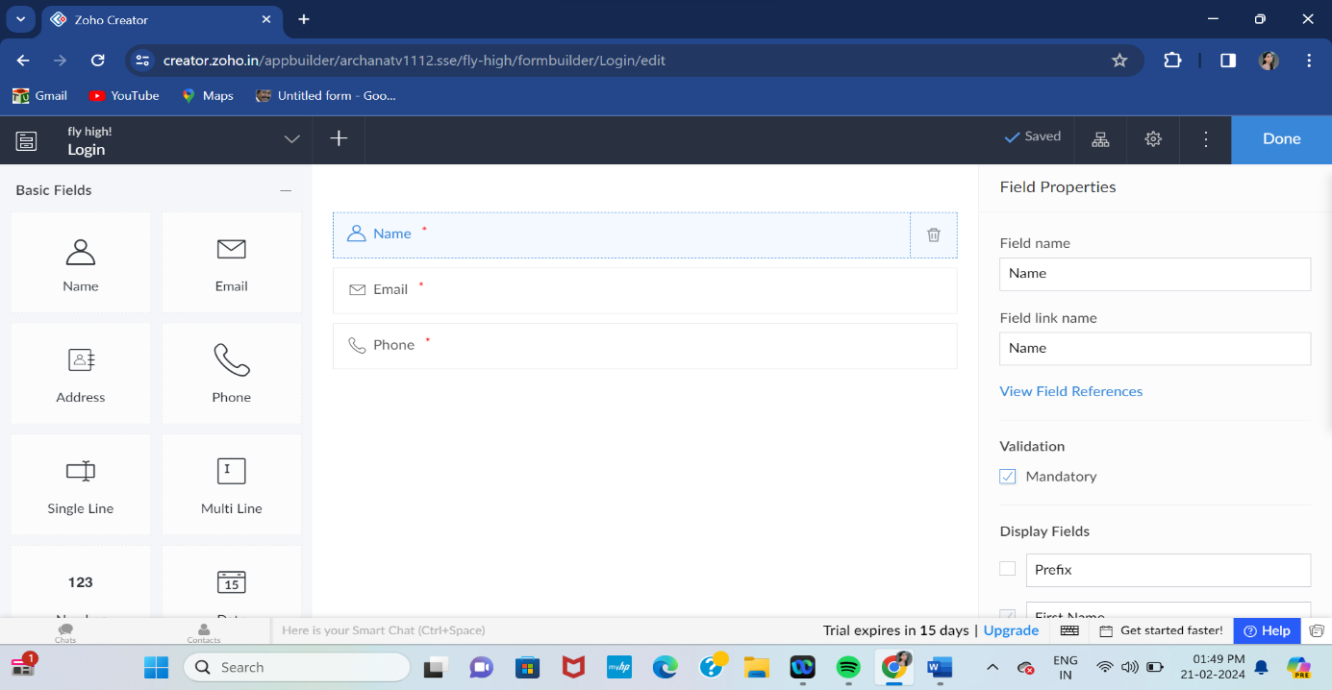

**STEP 5:**

After adding the fields go to the design page and view the alignment of the designed fields.

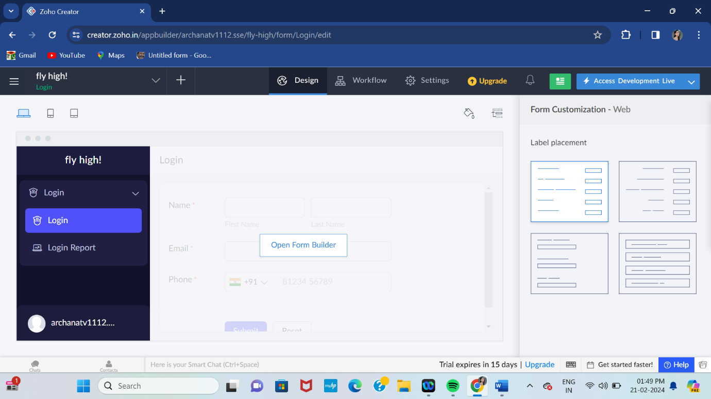

**STEP 6:**

Add another tab to create a new form for Ticket booking and insert the required fields.

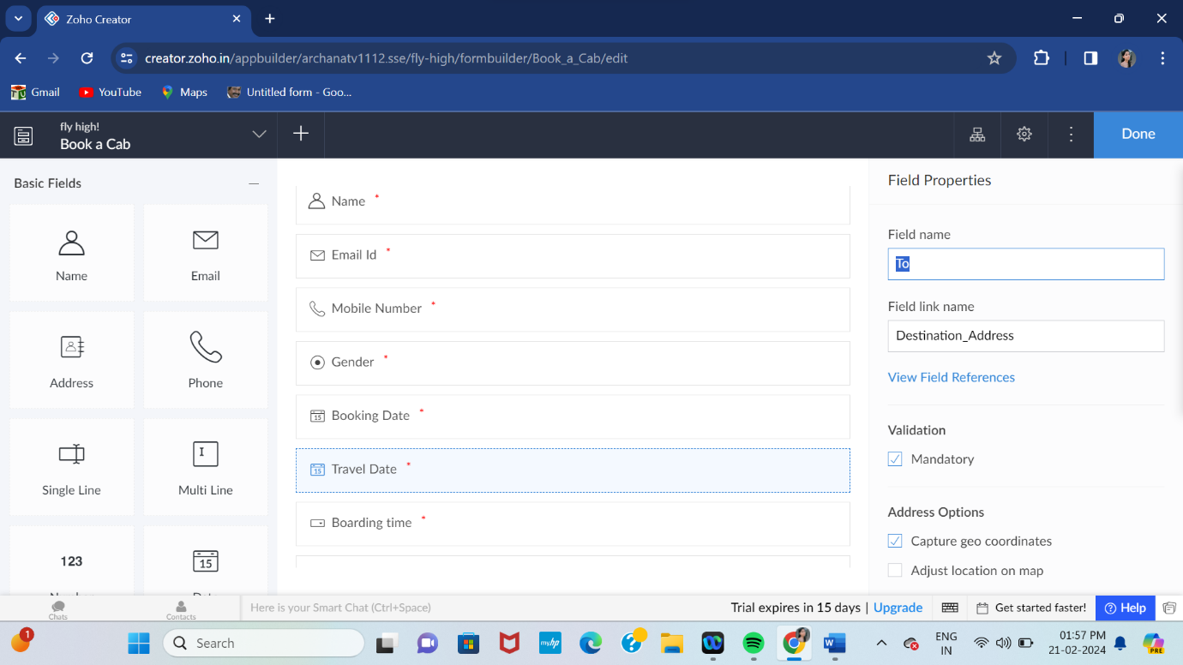

**STEP 7:**

After adding the fields go to the design page and view the alignment of the booking page.

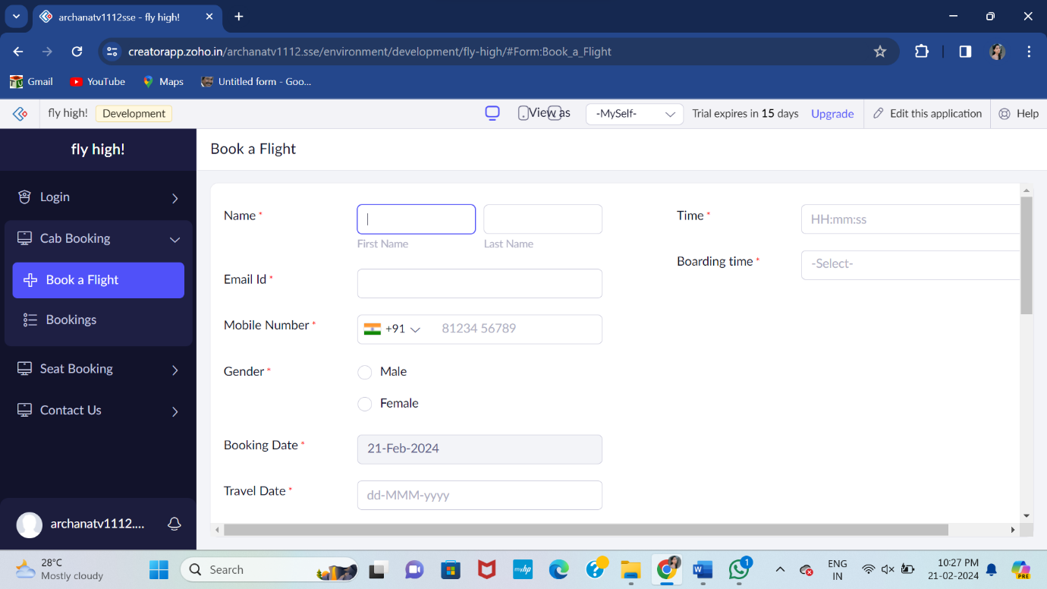

**STEP 8:**

Again create a new form for seat booking.

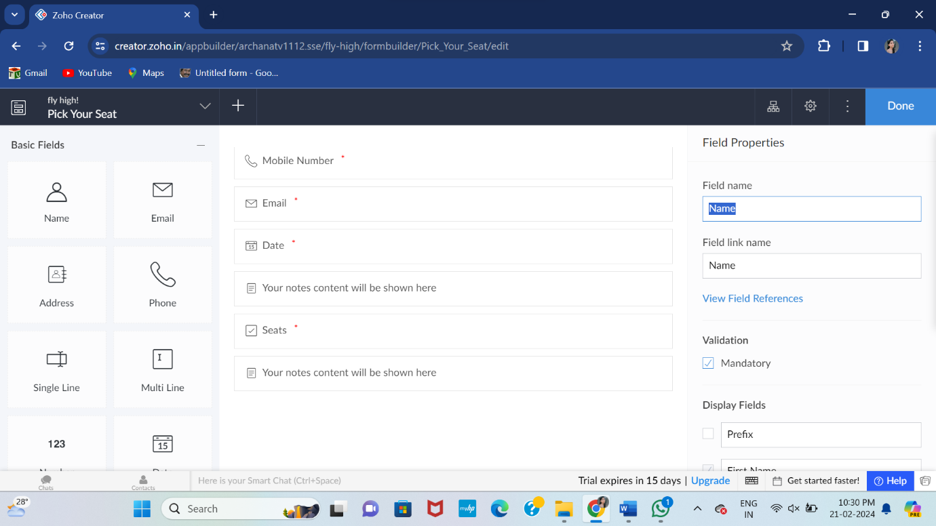

**STEP 9:**

View the alignment of the designed field of seat booking.

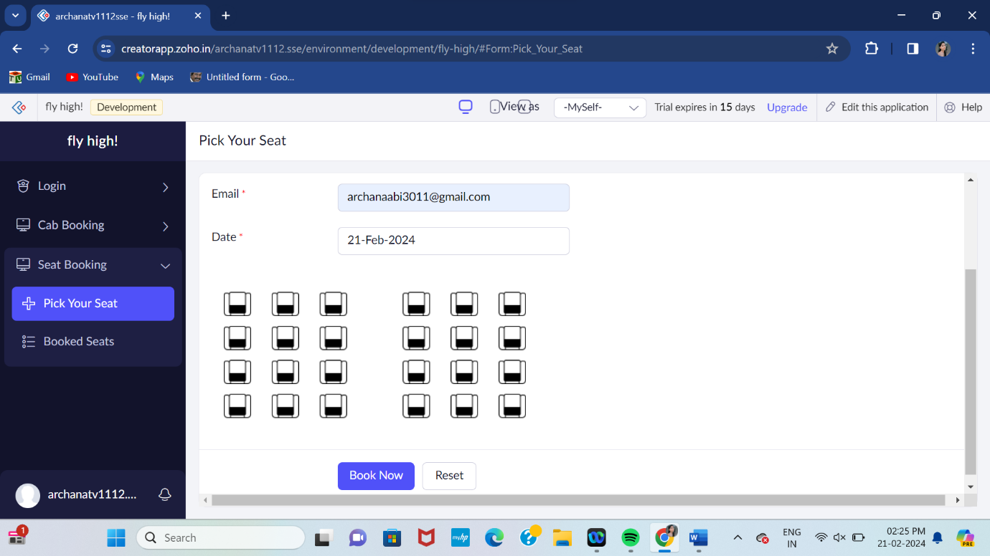

**STEP 10:**

Again create a new form for payment by choosing create from scratch and insert the required fields.

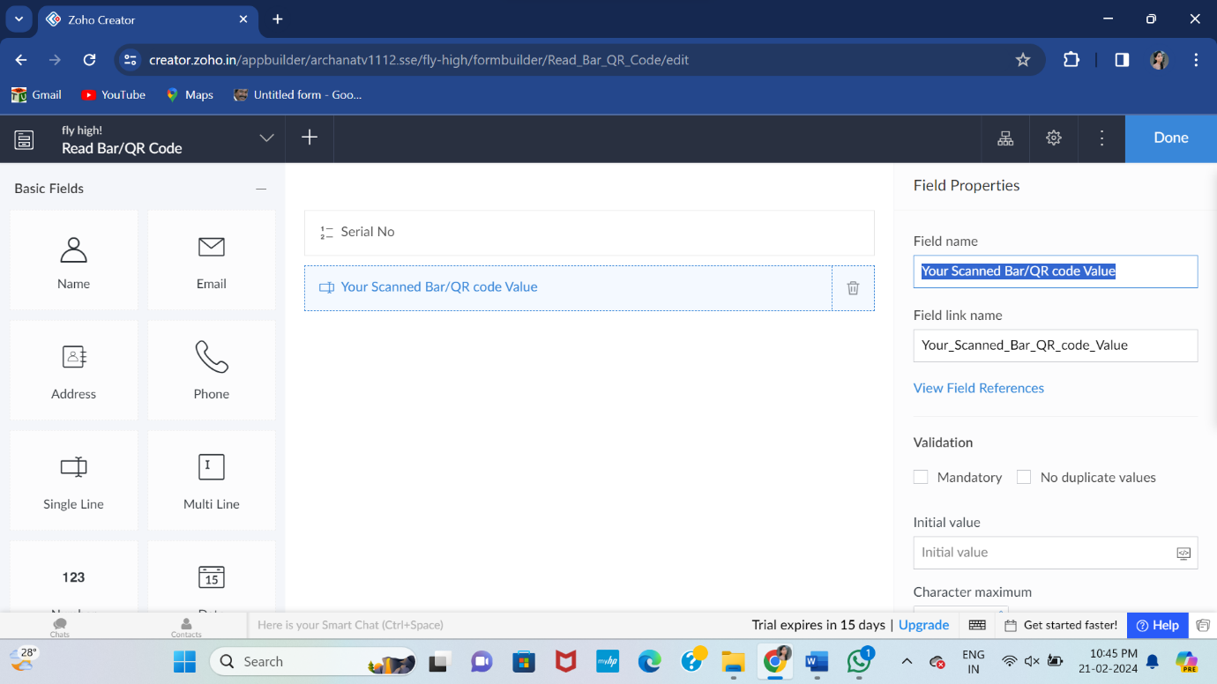

**STEP 11:**

Click to view the alignment of the designed field of payment page.

